CASE HISTORY
Name ___________________________________________________________________ Date _____________
Date of Birth ______________________ Age _______ Sex: M or F Marital Status: S M D W
Home Phone (__ )_____________Cell Phone ( __ )_____________Work Phone ( __ )_________________
Home Address ________________________________ City _________________ State ______ Zip _________
Occupation ___________________________ Employer ____________________________________________
Social Security # __________________ Driver’s License ____________ E~mail ________________________
Spouse’s Name __________________________________ Spouse’s Phone (work) ( __ )__________________
Relative Not in Household ______________________ Relationship ______________ Phone ______________
Person Responsible for Account _________________________ Relationship ___________________________
Referred to this office by __________________________ Past Chiropractic Care: ⁪ Yes ⁪ No When ____________
INSURANCE INFORMATION
Please plan to present your insurance card to the front desk assistant.
If insured is other than the patient:
Insured’s Name _________________________ Date of Birth _________________________
Employer ______________________________ Work Phone __________________________

Please list the problems you are seeing us for and circle a pain indicator.
Chief Complaint Pain scale: (0 = no pain, 10 = extreme pain)
1. ___________________________________ 0 – 1 – 2 – 3 – 4 – 5 – 6 – 7 – 8 – 9 – 10
2. ___________________________________ 0 – 1 – 2 – 3 – 4 – 5 – 6 – 7 – 8 – 9 – 10
3. ___________________________________ 0 – 1 – 2 – 3 – 4 – 5 – 6 – 7 – 8 – 9 – 10
4. ___________________________________ 0 – 1 – 2 – 3 – 4 – 5 – 6 – 7 – 8 – 9 – 10
Other doctors seen for this condition and when?
What was the treatment?
What were the results?
Are your present problems due to an injury? ⁪Yes ⁪No ⁪On the job ⁪Auto Accident ⁪Other
Has the accident been reported? ⁪Yes ⁪No ⁪Employer ⁪Auto Carrier ⁪Worker’s Comp ⁪Other
Are you now, or have you ever been disabled? (Service/Work) ⁪Yes ⁪No – When?
Have you retained an attorney? ⁪Yes ⁪No - Name ________________________Phone
Attorney’s address ______________________City _______________________ State _____ Zip

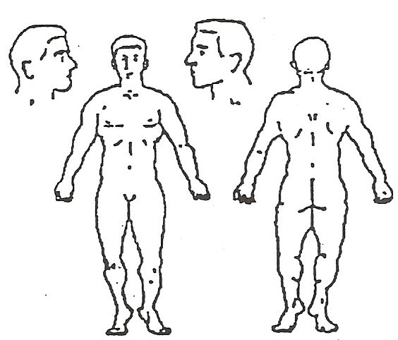
Please give most current date: Mark Pain Area
Spinal Exam ______ MALES ONLY N=Numbness
Disc. Exam ______ Prostate Exam ______ P=Sharp Pain
Lab Exam ______ FEMALES ONLY T=Tingling
Last Physical ______ Pap Smear ______ B=Burning
Breast Exam ______ D=Dull Pain
S=Stiffness
Current Weight _________________
Current Height _________________

Family History
Habits Amount of Exercise Diabetes Heart Kidney Cancer Scoliosis
⁪Alcohol drinks/week ______ ⁪Moderate Father ⁪ ⁪ ⁪ ⁪ ⁪
⁪Coffee Cups/day ______ ⁪Daily Mother ⁪ ⁪ ⁪ ⁪ ⁪
⁪Smoking Packs/day ______ ⁪None Siblings ⁪ ⁪ ⁪ ⁪ ⁪

PLEASE CHECK THE DISEASES YOU HAVE HAD

⁪Goiter ⁪Heart Disease ⁪Anemia ⁪Alcoholism ⁪Osteoporosis
⁪Polio ⁪Pleurisy ⁪Arthritis ⁪AIDS ⁪Scoliosis
⁪Epilepsy ⁪Rheumatic Fever ⁪Mental Disorder ⁪Venereal Infection
⁪Diabetes ⁪Tuberculosis ⁪Depression ⁪ Hepatitis
⁪Cancer: Where _______________________ Current Status ________________________________________
MARK ANY OF THE FOLLOWING YOU HAVE HAD IN THE LAST YEAR:
General Symptoms Gastro-Intestinal Eye/Ear/Nose/Throat Respiratory Muscles and Joints
__Headache __Poor Appetite __Poor Vision __Chronic Cough __Weakness
__Fever/Chills __Poor Digestion __Pain in Eyes __Spitting Blood __Twitching
__Night Sweats __Excessive Hunger __Deafness __Spitting Phlegm __Stiff Neck
__Fainting __Nausea/Vomiting __Earache __Chest Pain __Backache
__Dizziness/Vertigo __Vomiting Blood __Ear Noises Genito-Urinary __Hernia
__Convulsions __Pain over Stomach __Nose Bleeds __Frequent Urination __Swollen Joints
__Loss of Sleep __Constipation __Asthma __Painful Urination __Tremors
__Fatigue __Diarrhea __Frequent Colds __Blood in Urine
__Nervousness __Liver Trouble __Enlarged Thyroid __Kidney Infection
__Numbness/ pain in __Gall Bladder __Tonsillitis __Bed Wetting
Arms/Legs/Hands Trouble __Sinus Trouble __Inability to control Urine
__Neuralgia __Wheezing __Prostate Trouble
__Allergy _____________
Cardio Vascular Skin or Allergies FOR WOMEN ONLY CANCER WARNING SIGNALS
__Rapid Heart __Skin Eruptions __Painful Periods ⁪Change in bladder/bowel habit
__Slow Heart __Itching __Excessive Flow ⁪Sore that does not heal
__Heart Murmur __Bruising Easily __Irregular Cycle ⁪Unusual bleeding/discharge
__High Blood Pressure __Dryness __Hot Flashes ⁪Change in wart/mole
__Low Blood Pressure __Hives or Allergy __Cramps ⁪Indigestion/difficulty swallowing
__Pain Over Heart __Eczema __Backache ⁪Unexplained weight loss
__Previous Heart Trouble __Food Allergies __PREGNANT NOW? ⁪Nagging cough/hoarseness
__Strokes _______________ Due Date ________
__Swelling Ankles __Medicine Allergies
__Poor Circulation/ __________________
Varicose Veins
List any surgery or hospitalization (give dates)
List any accidents or falls (give dates)
List any broken bones (fractures) or dislocations
Have you ever had any spinal taps or spinal injections?⁪Yes ⁪No Were you ever knocked unconscious? ⁪Yes ⁪No
Have you ever had a lapse of memory? ⁪Yes ⁪No
Have you had X-rays taken in the last 2 years? ⁪Yes ⁪No – When?____________________By whom?
For what ailments were these X-rays made?
Do you suffer from any condition other than that for which you are now consulting us?
List any medications you are now taking – prescription and over-the-counter:

I understand and agree that health and accident insurance policies are an arrangement between an insurance carrier and me. I understand the Doctor’s office will prepare any necessary reports and forms to assist me in collection from the insurance company. Any amount authorized to be paid directly to the Doctor’s office will be credited to my account upon receipt. I understand and agree that all services rendered me are charged to me and I am personally responsible for payment. I understand if I suspend or terminate my care and treatment, any fees for professional services rendered me will be immediately due and payable. I understand should my case need to go to collection, there will be an additional 18% charge per annum.
I hereby authorize the Doctor to examine and treat my condition as he deems appropriate through the use of Chiropractic Health Care and I give authority for these procedures to be performed. It is understood and agreed the amount paid for the x-rays is for examination only and the x-ray negatives remain the property of this office, being on file where they may be seen at any time while a patient of this office. The patient also agrees that he/she is responsible for all bills incurred at this office.
Patient Signature _____________________________________________ Date _____________________________

